1. Research Purpose
This research folder gathers real, verifiable evidence about crime and community safety in Jukulyn and the wider Soshanguve area, in Pretoria, Gauteng. The purpose is to support the case for developing a community safety website and application for the Soshanguve Community Forum, an organisation made up of local residents who share safety alerts and respond to threats in their community.
All information below is drawn directly from South African news reports, government and police statements, and publicly available business listings. Where evidence is uncertain, incomplete, or specific only to Soshanguve generally rather than Jukulyn specifically, this is stated clearly rather than presented as fact.

2. Organisation Background
The Soshanguve Community Forum is a group of concerned residents in Soshanguve who currently coordinate around safety using phone calls, SMS, WhatsApp messages, and whistle-blowing when a threat or crime is happening. Many members are unemployed, which means they are often available to respond quickly, but it also means many cannot afford data or airtime — leaving them dependent on shouting or blowing whistles to alert others nearby. The Forum has no website or app at present.

3. Crime Situation in Jukulyn
Jukulyn is a section of Soshanguve that has repeatedly been singled out by name, in separate reports, as the area's most dangerous pocket. In January 2024, Gauteng Premier Panyaza Lesufi described the crime rate in Jukulyn as alarming after four people, including a 14-year-old girl and an off-duty police officer, were shot dead at Block P in the early hours of New Year's Day. At the time, officials indicated the area had over 300 active criminal cases.
Reporting from Tshwane Bulletin describes Jukulyn as a no-go area where residents returning from work are targeted for robbery, and where refusing to hand over belongings can lead to violence. The same reporting links much of the area's crime to turf disputes between rival groups over drug sales, with local businesses allegedly forced to pay protection fees, in some cases leading spaza shops to close down.
A further report from early 2024 described allegations that children as young as 12 had been recruited into crime syndicates operating in Jukulyn, reportedly trained to use firearms for robberies.
By mid-2024, official SAPS station-level statistics for the Rietgat policing area, which covers Jukulyn, recorded a 35% increase in contact crimes over the prior year, driven mainly by assault with intent to cause grievous bodily harm, common assault, and robbery.

4. Crime Situation in Soshanguve
Beyond Jukulyn specifically, Soshanguve as a whole has consistently featured among Gauteng's most crime-affected police precincts in SAPS quarterly statistics. A November 2024 report on the second-quarter 2024/25 statistics placed Soshanguve station among the province's 30 most crime-affected stations, with contact crimes up 4.6% yearon-year, assault with intent to cause grievous bodily harm up 41.3%, and reported sexual offences up by nine cases.
Several individual, named incidents illustrate the pattern across Soshanguve more broadly, not only Jukulyn: June 2024: two young girls, aged four and seven, and two other people were murdered in Soshanguve; a
35-year-old suspect was later arrested in Akasia.
March 2025: five-year-old Ditebogo Junior Phalane was shot and killed during a hijacking of his father's vehicle outside their home, an incident that prompted the deployment of a dedicated SAPS stabilisation task team to Soshanguve, Rietgat, Loate, and Mabopane.
● May 2025: a group of Soshanguve South Secondary School learners opened a criminal case after community members, reportedly acting as informal 'scholar patrollers,' forcibly entered the school and assaulted learners for arriving late.
A general online summary (Grokipedia) corroborates that Soshanguve, as recorded by SAPS, experiences elevated levels of contact crimes including murder, aggravated robbery, and assault with intent to cause grievous bodily harm; this source should be treated as a secondary, non-official summary rather than a primary record.

5. Mob Justice
Vigilantism and mob justice are documented, serious problems in South Africa generally. According to Wikipedia's summary of Institute for Security Studies research, mob violence and vigilante attacks are estimated to cause at least two deaths a day nationwide, and SAPS itself linked at least 1,894 of the 27,000 murders recorded in 2022 — roughly 7% — to mob justice or vigilantism, more than double the proportion recorded a few years earlier.
A specific, well-documented mob justice case tied directly to Soshanguve is the killing of a part-time Tshwane
University of Technology (TUT) lecturer. According to News24, nine people — referred to in reporting as the 'Soshanguve 9' — appeared at the Soshanguve Magistrate's Court in March 2026 in connection with the lecturer's killing during what News24 describes as a vigilante attack. The nine denied involvement at that hearing and were later granted bail. Because the underlying News24 article sits behind a subscriber paywall, the fuller narrative of events was not accessible for this research; only the confirmed facts above could be verified.
Separately, in March 2025, a group of community patrollers on a routine safety walkabout in Soshanguve's Marry Me informal settlement were attacked by a group of individuals; six patrollers died and several more were injured, with victims reportedly stoned, shot, and partially burned. While this incident is not itself an act of mob justice by the patrollers, it illustrates the same underlying dynamic the research was asked to investigate: residents stepping into community safety roles in the absence of adequate police presence, and paying a severe price for it. Gauteng's Community Policing Forum board has publicly cautioned residents against forming informal, unregistered safety groups, recommending instead that volunteers join a registered Community Policing Forum (CPF) for legal protection, insurance, and training.
No verified, named incident of Jukulyn-specific vigilante violence (as opposed to Soshanguve-wide) could be confirmed through this research. This should be stated plainly in the final proposal rather than substituted with the TUT lecturer case, which occurred at the Soshanguve Magistrate's Court but whose underlying incident location within Soshanguve was not confirmed in the available reporting.

6. Police and Government Response
Government and police attention to Jukulyn and Soshanguve has been extensive and repeated over several years, a pattern that itself supports the argument that existing interventions have not resolved the underlying problem:
- July 2023: National Police Minister Fikile Mbalula hosted a Ministerial Imbizo in Soshanguve, alongside crime prevention roadblocks and unannounced station visits, in response to community complaints about crime and substance abuse.
- April 2024: Deputy Police Minister Cassel Mathale held a ministerial community imbizo at Soshanguve Block X Community Hall, committing to recall retired detectives to help clear over 300 active cases in Jukulyn.
- May 2024: Gauteng Community Safety MEC Faith Mazibuko held a further crime imbizo (branded '#SlyzaTsotsi') at Thakgalang Secondary School in Jukulyn, launching a panic-button app and CCTV cameras for Soshanguve Block P, in partnership with Tshwane Metro Police, SAPS Crime Prevention Wardens, and Gauteng provincial patrollers. Mazibuko stated that ten private security companies were working alongside law enforcement to respond to panic-button alerts.
- 2024: A national SAPS Stabilisation Team, including Crime Intelligence, the Flying Squad, K9 units, and drone support, was deployed specifically to Soshanguve, Rietgat, Loate, and Mabopane; by November 2024 it had registered over 200 documented successes.
April 2025: Gauteng e-Government launched the Gauteng e-Panic Button app specifically for Soshanguve's Marry Me informal settlement, following the patroller killings, giving residents a direct digital way to alert emergency services.
- July 2025: field testing of the panic-button response reported response times of roughly two to five minutes, varying by location, with community members expressing mixed confidence in the tool's realworld effectiveness.
A recurring theme in the reporting is residents' frustration that repeated imbizos and government visits have not translated into a lasting change in daily safety, with an April 2025 opinion piece in The Star describing promises made at successive imbizos as largely unfulfilled from residents' point of view.

7. Community Concerns
- Residents report that suspects and perpetrators are frequently known to the community by name, but people are too afraid of retaliation to report them to police.
- Some residents allege that criminals operate with the knowledge, or even the cooperation, of corrupt local police officers.
- Slow police response times and case backlogs are repeatedly raised; in one Rietgat-area report, only two of 197 murder investigations had reached court in a single quarter.
- Community safety volunteers (patrollers and CPF members) face real danger carrying out this work without formal protection, insurance, or training, as shown by the March 2025 patroller killings.
- Basic service delivery failures — inadequate waste removal, untarred roads, and lack of lighting — are frequently raised alongside crime concerns at community imbizos, suggesting safety concerns are linked to broader infrastructure neglect.

8. Existing Communication Methods
Based on organisational information provided by the Soshanguve Community Forum itself, current safety communication in the community relies on:
- Phone calls between residents
- SMS messages
- WhatsApp group messages
- Physical whistle-blowing to alert nearby residents when no data or airtime is available
This is corroborated by external evidence: the Gauteng e-Panic Button app and the CCTV/panic-button rollout in Block P were both introduced specifically because existing community communication (word of mouth, informal patrols, and manual alerts) was not fast or reliable enough during emergencies.

9. Website Opportunity Identified
The evidence gathered supports the case for a free, accessible community safety website and app for the Soshanguve Community Forum, for several concrete reasons:
- Government's own panic-button and CCTV interventions (2024–2025) confirm that officials themselves consider a digital, real-time alert tool necessary in this exact community — the Forum's proposal is aligned with an approach government has already validated, not an unproven idea.
- Existing government tools (the Gauteng e-Panic Button) are area-specific pilots (e.g. limited initially to Marry Me and Block P) and are not confirmed to cover the whole of Soshanguve or to be built around the Forum's own network of members and volunteers.
- The data/airtime barrier facing unemployed residents, identified by the Forum, is not addressed by existing panic-button tools, which still require a working smartphone connection — a free, low-data web presence, alongside the app, could reduce this gap.
- The pattern of danger faced by informal patrollers (March 2025 killings) shows a clear need for a tool that supports incident reporting and community announcements without requiring residents to physically confront threats.
No dedicated Soshanguve Community Forum website currently exists, despite the organisation's ongoing, real activity in the community.
10. Evidence Table

11. Mob Justice Evidence Table

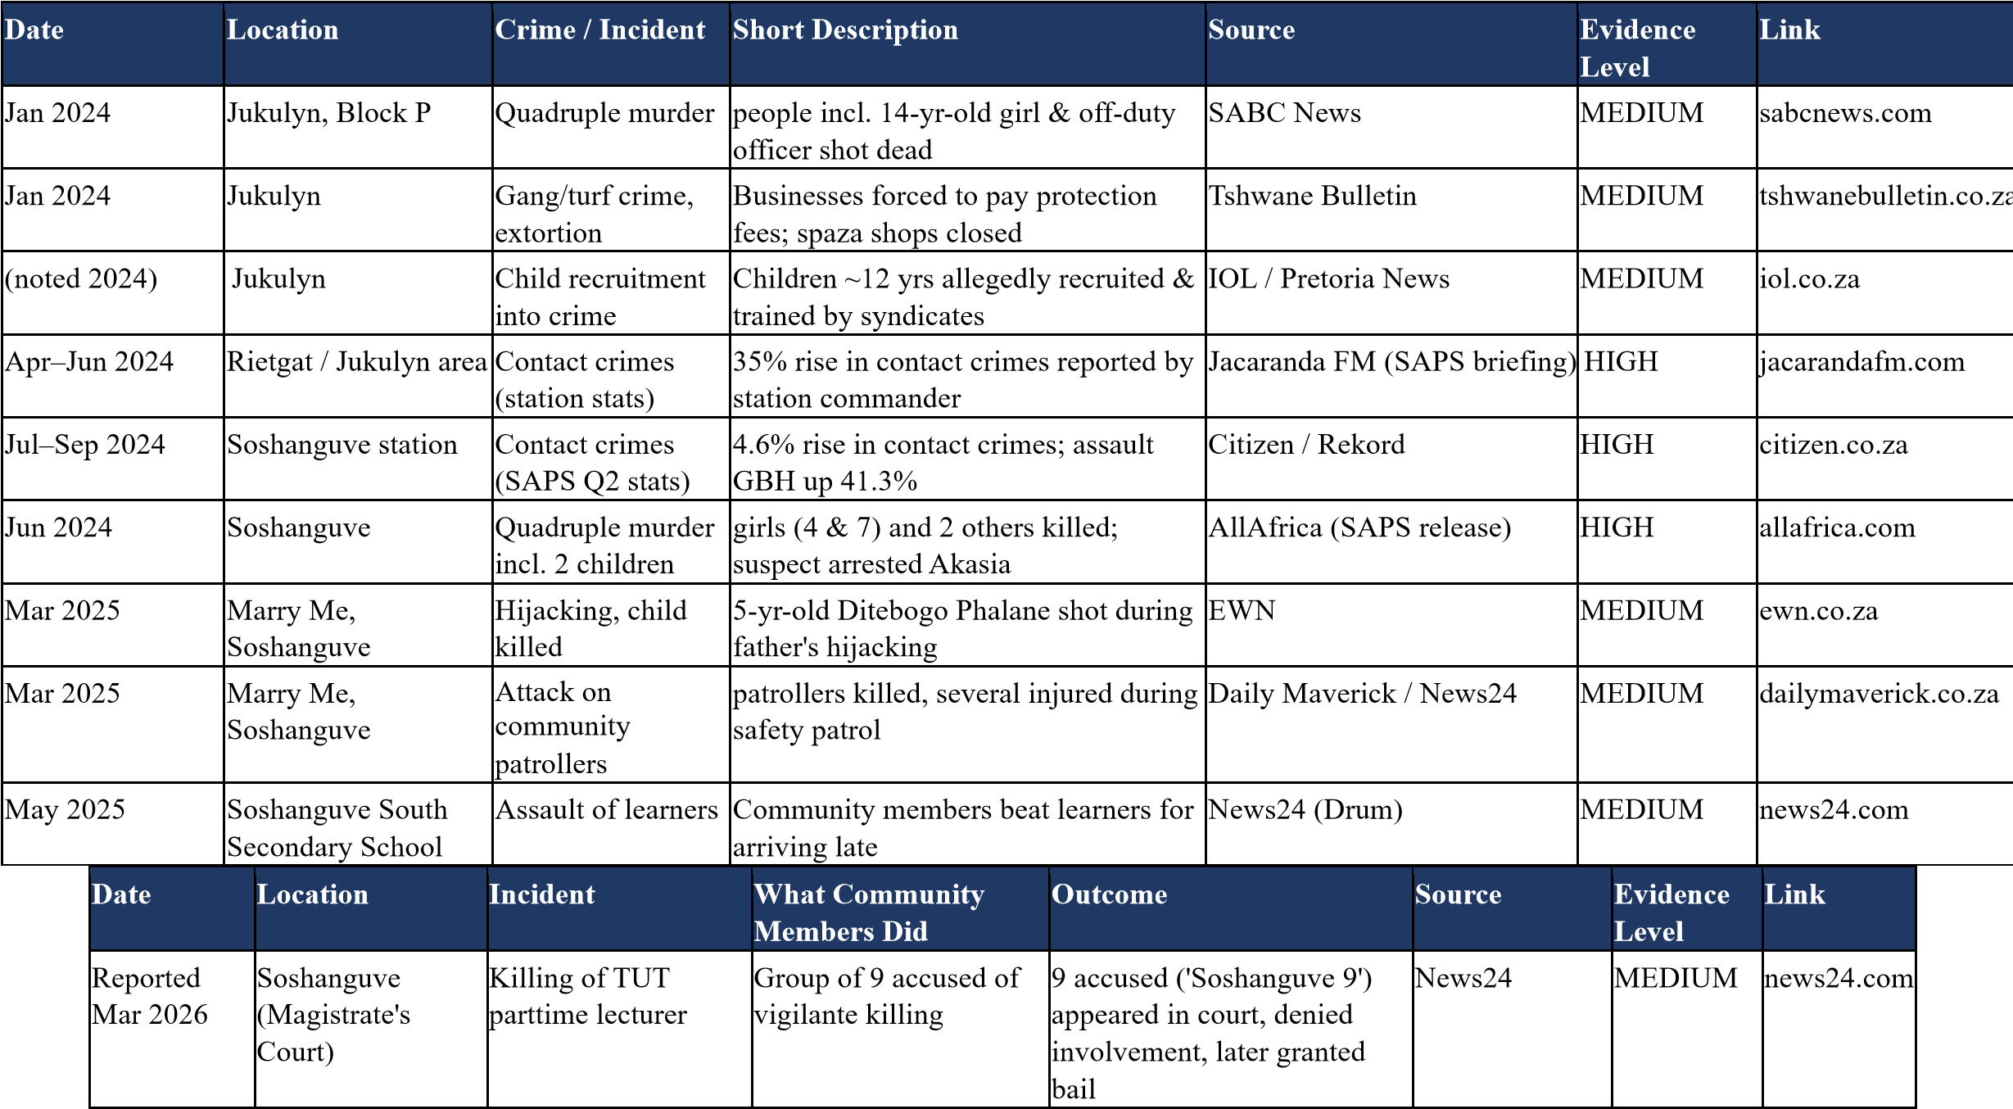

General South African context (not Soshanguve-specific, included as background statistics only):
- Institute for Security Studies research, cited via Wikipedia, estimates at least two deaths per day nationally from mob violence or vigilante attacks.
- SAPS-linked figures indicate roughly 7% of South Africa's ~27,000 murders in 2022 (about 1,894 cases) were attributed to mob justice or vigilantism — more than double the proportion a few years prior.

12. Private Security Companies Operating In or Around Soshanguve / Jukulyn
The following security-related businesses were identified as currently serving the Soshanguve area through business directories and news coverage. Contact details and exact service areas should be independently verified before being relied on for the final proposal, as directory listings change frequently.
Company | Area Served | Services | Source
Moshate Security | Soshanguve / Mabopane (incl. Block L) | Suspect tracing & arrest support, general security | TikTok / Mabopane Daily News coverage

Cop Watch | Soshanguve (listed on Procompare directory) | Armed guarding, general security services | Procompare.co.za directory
Jabu's Safety Sure | Pretoria area, incl. Soshanguve | Security products & solutions, alarms | Procompare.co.za directory
Africa Security Service | Soshanguve (client request logged) | Armed response | Procompare.co.za provider page
Ten unnamed private security companies (Dept. of Community Safety) | Marry Me / Jukulyn, Soshanguve | On-call panic-button emergency response, alongside SAPS | Tshwane Bulletin, citing  Gauteng Dept. of Community  Safety

For broader national context: South Africa's private security industry is the largest in the world by registered personnel, with over 10,000 registered companies and roughly 2.5 million registered guards, of whom around 556,000 are currently active — several times the combined size of SAPS and the South African National Defence Force. This industry growth is widely linked to under-resourcing of public police and high crime levels, which mirrors exactly the gap the Soshanguve Community Forum's proposed website/app aims to help close for residents who cannot afford private security.

13. Image Evidence

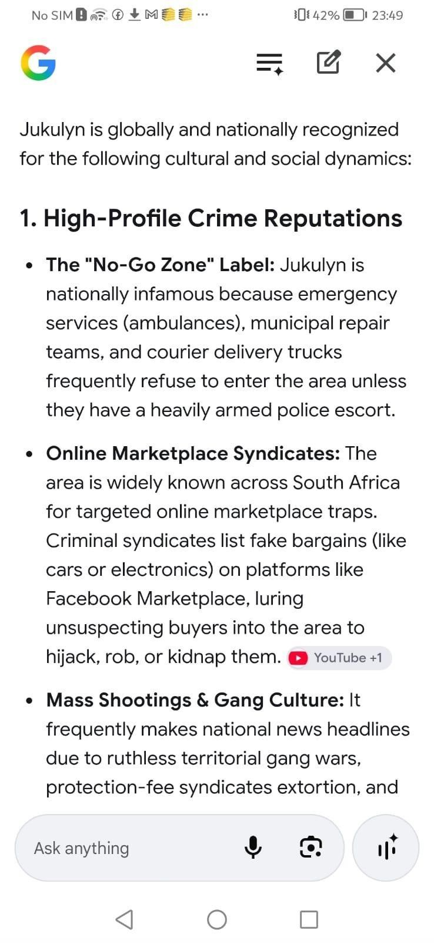

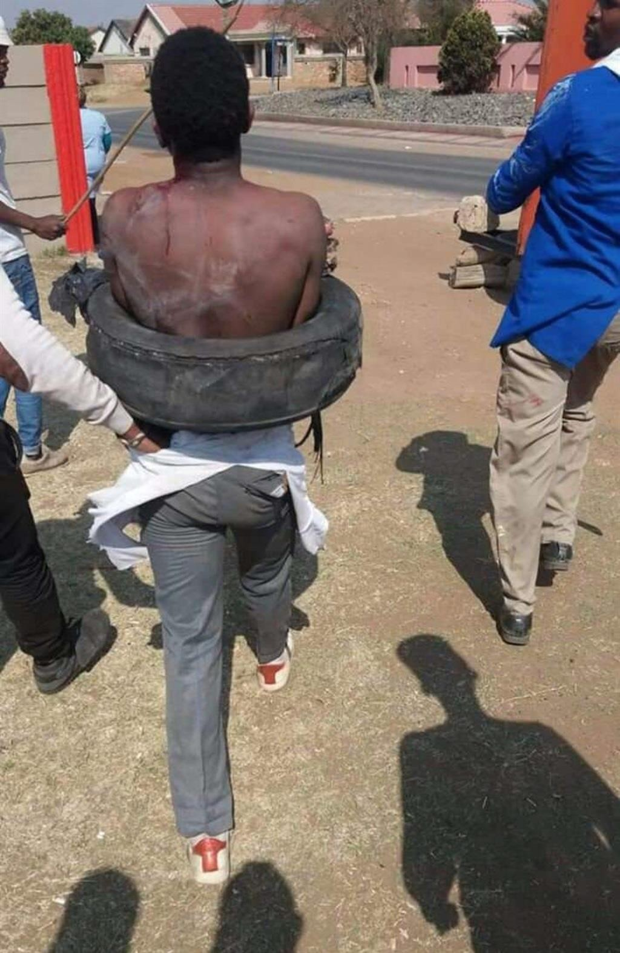

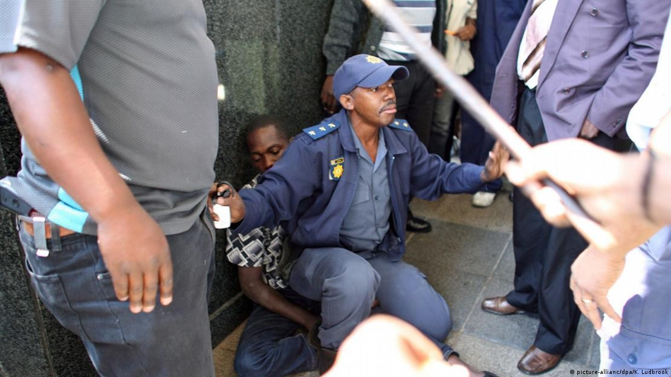

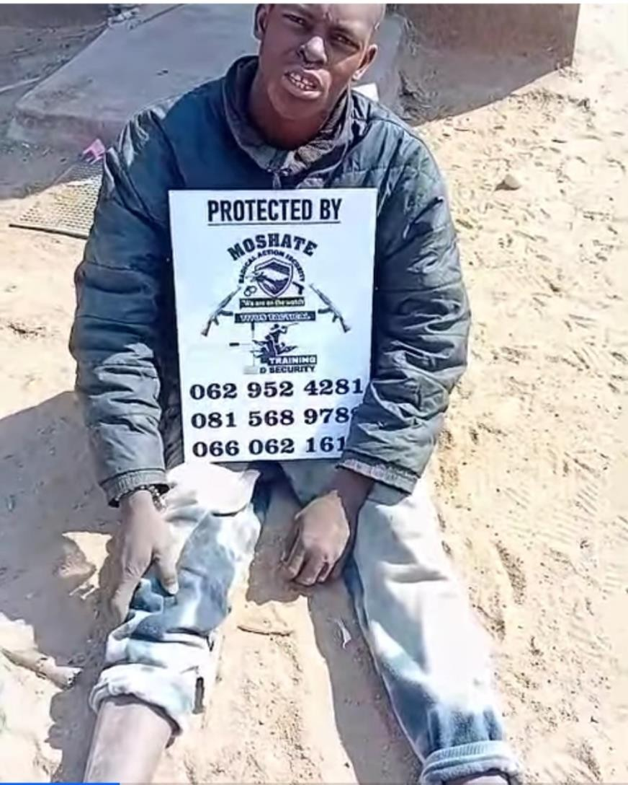

Moshate security company on duty

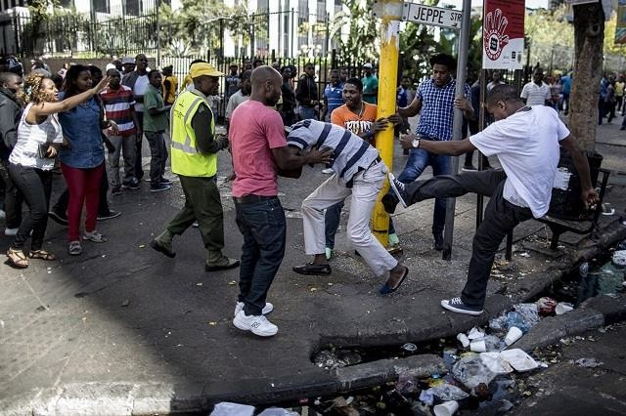

Community found someone stealing
Through verbal communication they caught the criminal
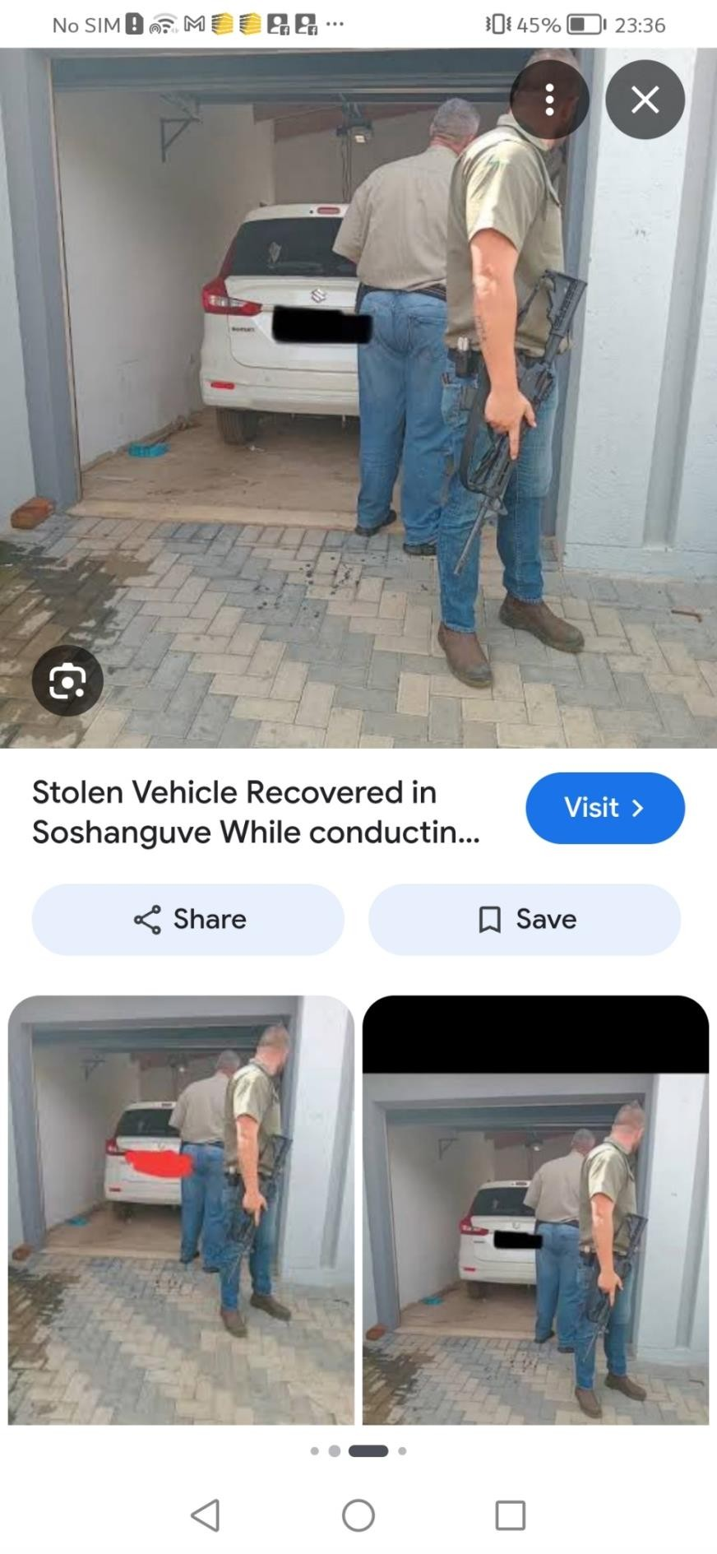

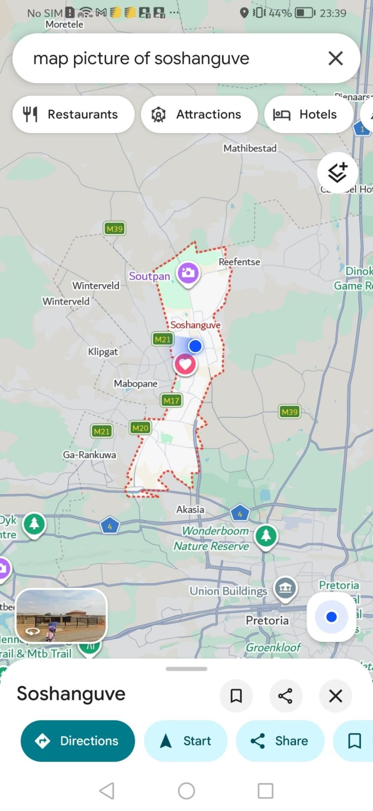 this is how big Soshanguve is ,on google maps



Moshate security compony protecting the community against criminal

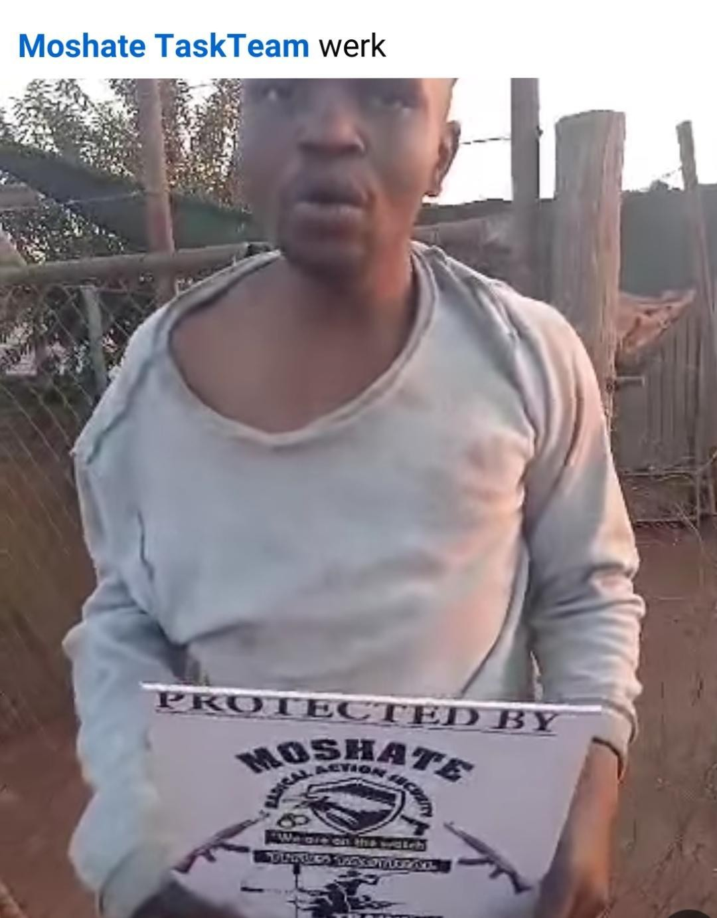

The most dangerous location in Soshanguve corner of batho plaza the very center of jukulyn

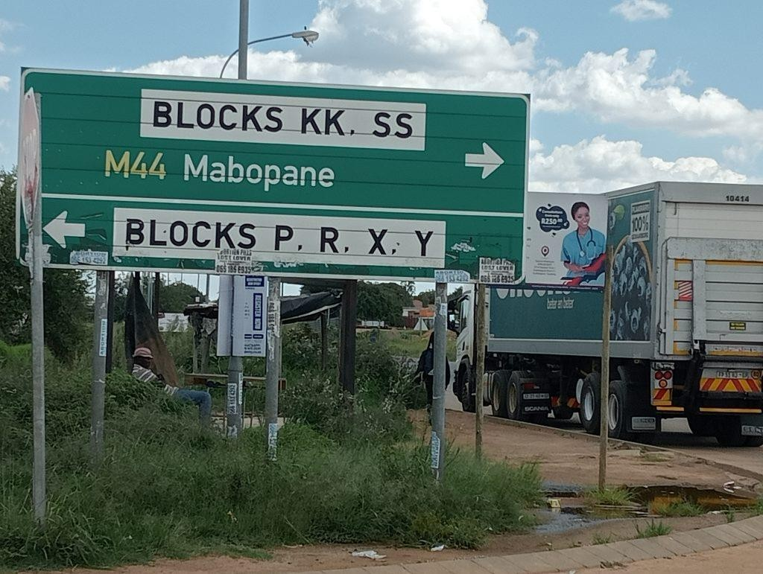

1.4

References
All sources below were accessed on 20 August 2026. Full APA/Harvard formatting should be finalised to match your institution's required referencing style before submission.
SABC News (2024) — Lesufi denounces crime rate in Soshanguve's Jukulyn section.
Tshwane Bulletin (2024) — JUKULYN | Residents of Soshanguve suffer the most violent crimes in this area.
IOL / Pretoria News (2025) — Innovative app and community patrols tackle rising crime in Jukulyn.
Citizen / Rekord (2024) — Noweto stations indicate increase in contact crimes.
Jacaranda FM (2024) — GP community safety committee visit crime-ridden Soshanguve.
AllAfrica / SAPS (2024) — Gauteng Police arrested one suspect linked to murder of two children and two other people in Soshanguve.
EWN (2024) — Widespread crime pushes Soshanguve residents over the edge.
Daily Maverick (2025) — Soshanguve patroller murders: Suspect arrested, 2 questioned.
News24 (2025) — Soshanguve learners open case against community members after beatings for lateness.
Wikipedia (2026) — Mob justice in South Africa.
News24 (2026) — Soshanguve 9 deny involvement in mob killing of TUT lecturer.
Tshwane Bulletin / Daily Sun (2024) — Jukulyn's cry for safety heard.
IOL (2024) — Government addressing rampant crime at Soshanguve's Jukulyn.
Tshwane Bulletin (2025) — BREAKING | Gauteng Launches e-Panic App to Tackle Crime in Soshanguve.
Tshwane Bulletin (2025) — Soshanguve Crime-Fighting Tool Faces Mixed Reaction.
The Star (2025) — Neglected Soshanguve residents face safety and service delivery challenges while Lesufi fails to deliver promises.
Wikipedia (2026) — Private security industry in South Africa.
Procompare.co.za — Top 20 Security companies Soshanguve, 2025.
EWN (2025) — Memorial service for murdered Soshanguve patrollers to get underway.

